Dessa Shapiro

12/18/19

Period 4&6 english

Lies

I've been reading the book Counting by 7s by Holly Goldberg Sloan. At the beginning of the book, we are introduced to Willow Chance (the protagonist). We learn willow is an adopted gifted young girl that lives in Bakersfield, California with her parents. The conflict in the inciting moment is when we learn that both of her parents had died in a car accident. I’m currently in the rising action of the book and willow is struggling through the pain of losing everything she has while also trying to find a permanent place to stay. She is currently living with her friend. I don’t think the book has hit the climax yet. I think the main conflict is an internal conflict between Willow’s pain and her logical thinking. Currently, Willow is with her friend's mom Miss. Kim, who owns a nail salon. Since Willow is refusing to go back to school Miss. Kim takes her with her to the salon.

“The pain for me is seeing how they are so connected. To one another. And to their families. And to the world. These women wrap themselves in their stories from the minute they walk through the glass door until the second they leave at the end of the day. They use words to build something as real as cloth...They are part of something bigger than themselves. Even if they don’t realize it. I do.”(pg. 183-184)

I feel that I can relate to this passage because willow is talking about how people can be connected through the way they communicate and even if they aren't related to just have one thing in common they can connect, can form an almost physical bond. Throughout my life, in middle and high school I've always felt I wasn't able to make strong connections with people. I figured this was because I never knew how to start conversations and that enabled me to build a confident strong relationship with them. I struggled with social anxiety for a long time, and I would see people easily getting along with others and become frustrated, I wasn't able to replicate these experiences. For a while, I tried to change myself and become more like my extroverted friends, but I started to lose myself in the process. When I started 8th grade I decided that I didn't want to change myself to build connections because the connections I made as, “the new me” would still be fake. As soon as I changed back and started to focus less on others and pursue my interests, I found people that I could connect with. I realized that the only way to make connections “as real as cloth” was to be myself and to allow others to be themselves around me.

I think I also feel that this passage spoke to me because the author used a very unique writing style. I can tell that she used listing the make a point and to make the short sentences more impactful. I also really liked the metaphor she used to describe relationships, comparing them to the cloth. I’ve noticed through the book so far the author likes to use a lot of metaphors and similes to describe things better.

**Dear Insecurities by Gnash**

I chose this song because it relates to being insecure and not sure about yourself.

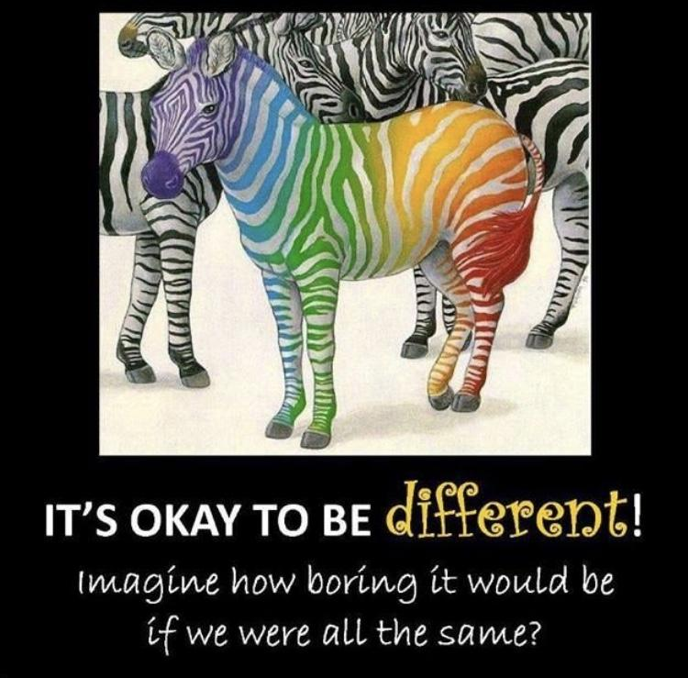

This is a picture I saw in my teachers classroom a few years ago and I think it represents that it’s ok to be different.